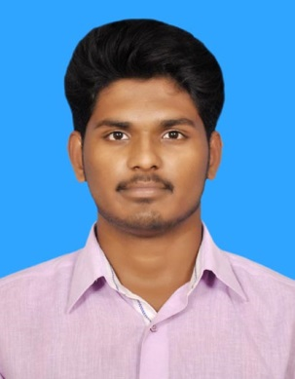 R.VIGNESH,
S/o R.ramesh,
5A1,Udaiyanachi Pudhur
Nagalur (post),
kallakurchi (Tk), Villupuram (DT).
Pin 606 203.
Mobile: 9786360813, 8015473214
E-mail: vigneshrajj020697@gmail.com

OBJECTIVE
To work in the competitive environment where I can share my creative skills and knowledge and to be part of team that helps to achieve the success.

ACADEMIC PROFILE

degree / class | NAME OF THE  INSTITUTION | university/ BOARD | YEAR OF passing | PERCENTAGE
Bsc computer science | Sri lakshmi college of Arts & Science,  Bangaram,  Kallakurichi. | Thiruvalluvar  University | 2015-2018 | upto 5th sum  65%
HSC | A.K.T ACADEMY Matric Higher Secondary School, kallakurichi. | State Board | 2015 | 60 %
SSLC | A.K.T ACADEMY Matric Higher Secondary School, kallakurichi. | State Board | 2013 | 60.1 %

EXTRA CURRICULAR ACTIVITIES
- National Cadet Corps(NCC) grade-B

TECHNICAL SKILLS
- Operating Systems : Microsoft Windows XP, 7, 8,

- Programming Language : C, C++, and JAVA.

AREA OF INTREST
- Computer Hardware & Networking.

ABOUT MYSELF
- I am interested to learn new technologies.
- Am sincere, hardworking and responsible person.
- My positive is frank to everyone and my negative same is the same because someone couldn’t like my frankness.

PERSONAL PROFILE
Father’s Name : Mr. Ramesh .R
Date of Birth : 2/06/1997.
Age : 20 years.
Sex : Male.
Nationality : Indian.
Languages known : English, Tamil, telugu.
Hobbies : picture editing and playing cricket.
Permanent Address :
5A1, Udaiyanachi Pudhur,
Nagalur (post),
Kallakurichi (Tk),
Villupuram ( Dt),
Pin 606 203.

DECLARATION
I hereby declare that the above mentioned information is true to best of my knowledge.
Thank you,

PLACE: kallakurichi. Yours truthfully,
DATE:
( Vignesh .R )

